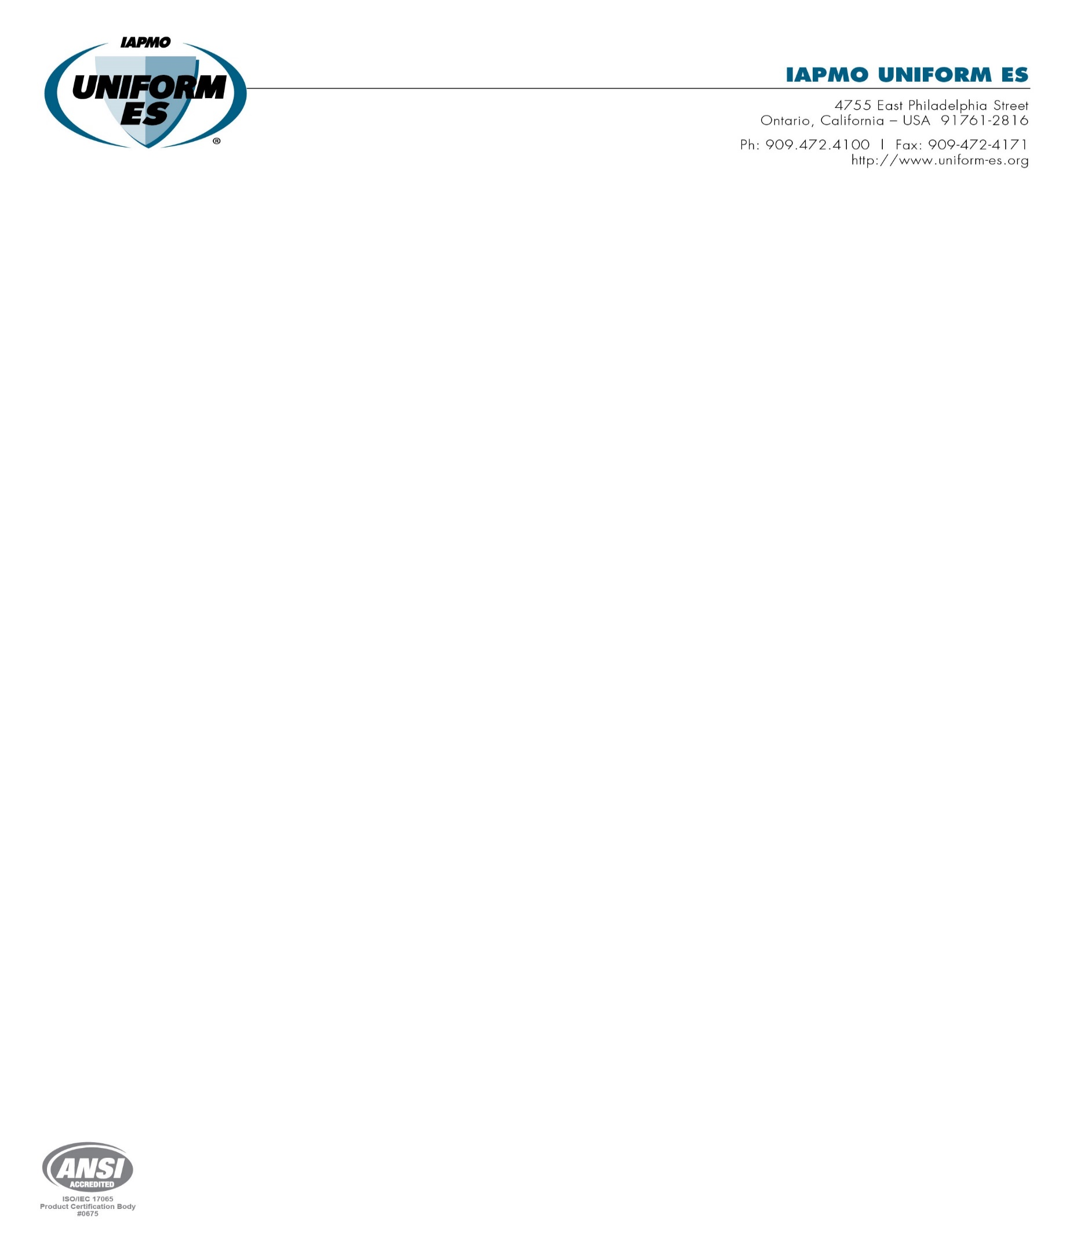

INTERNATIONAL ASSOCIATION OF PLUMBING AND MECHANICAL OFFICIALS
UNIFORM EVALUATION SERVICES

EVALUATION CRITERIA FOR
TEMPORARY CEILING CONSTRUCTION BARRIERS

EC 043-2026
(Adopted October 2020, Revised April 2021)

  - Purpose: The intent of this criteria is to establish requirements for membranes used as temporary ceiling construction barriers recognized in an evaluation report independently reviewed and issued by an evaluation service agency under the 2024, 2021, 2018, and 2015 International Building Code® (IBC), the International Residential Code® (IRC), and the International Fire Code® (IFC). The bases of recognition are 2024 IBC Section 104.2.3 (2021, 2018, and 2015 IBC Section 104.11), 2024 IRC Section R104.2.2 (2021, 2018, and 2015 IRC Section R104.11), and 2024 IFC Section 104.2.3 (2021 IFC Section 104.10, 2018 and 2015 IFC Section 104.9).

  - Scope: This evaluation criteria applies to horizontally suspended membranes used as temporary ceiling construction barriers in the interior of a structure. The membrane is supported in sheets, with seams between membrane sheets, designed and manufactured to release in the event of a fire or sprinkler operation. Individual sheets are suspended from the supporting structure so that in the event of seam release (fire or sprinkler operation) the sheets do not interfere with egress and sprinkler performance. This criteria provide guidelines to evaluate the performance, strength, egress, and fire safety of interior temporary ceiling construction barriers.

    - Limitations:

1.2.1.1 Ceiling construction barriers shall be for temporary permitting purposes only and shall be for use in structures for a period of less than 180 days as defined by Section 3103.1 of the IBC.

1.2.1.2 Use of temporary ceiling construction barriers as part as a fire-resistance-rated assembly is outside the scope of this criteria.

1.2.1.3 The products evaluated in this criteria shall be for interior use only.

1.2.1.4 The products evaluated in this criteria have not been evaluated to carry imposed loads and are not intended for structural use.

  - Definitions: For terms not defined in this section, applicable codes, or referenced standards shall have the ordinary accepted definition for the context for which they are intended.

    - Barrier Type: Each Barrier material having a single formulation or chemical make-up and composition with identical raw material quantities including reinforcement.
    - Barrier System: System that includes identical barrier seams, barrier seam material, membrane supporting methods, and installation.
    - Ceiling Construction Barrier: A sheet type membrane used to mitigate dust and debris, when used to physically separate an area below the barrier from a work-zone located above the barrier.
    - Evaluation Service Agency: Organization evaluating building products or finished construction for conformance to applicable codes and standards and publishing report or listing documents summarizing conclusions. The agency shall be accredited for the applicable product scope in accordance with ISO/IEC Standard 17065. The agency’s accreditation shall be issued by an accreditation body conforming to ISO/IEC 17011 and that is a signatory of the International Laboratory Accreditation Cooperation (ILAC) Mutual Recognition Arrangement (MRA) or another approved agency.
Copyright © 2021 by International Association of Plumbing and Mechanical Officials. All rights reserved. Printed in the United States. No part of this publication may be reproduced, stored in an electronic retrieval system, or transmitted, in any form or by any means, electronic, mechanical, photocopying, recording, or otherwise, without the prior written permission of the publisher. Ph: 1-877-4IESRPT • Fax: 909.472.4171 • Web: www.iapmoes.org • 4755 East Philadelphia Street • Ontario, California 91761-2816 ––USA

- REFERENCED STANDARDS

Apply standards in accordance with the specific edition of the code(s) for which the Evaluation Report is prepared unless otherwise approved by the Evaluation Service Agency.

  - ASTM International
    - ASTM E84 Standard Test Method for Surface Burning Characteristics of Building Materials
    - ASTM E330 Standard Test Method for Structural Performance of Exterior Windows, Doors, Skylights and Curtain Walls by Uniform Static Air Pressure Difference
    - ASTM D8662-26 Standard Specification for Plastic Temporary Ceiling Construction Barriers for Installation Below Automatic Sprinklers

International Code Council
    - International Residential Code®, (IRC), 2024, 2021, 2018, 2015
    - International Building Code®, (IBC), 2024, 2021,2018, 2015
    - International Fire Code®, (IFC), 2024, 2021,2018, 2015

International Organization for Standardization
    - ISO/IEC 17011:2017, Conformity Assessment, General Requirements for Accreditation Bodies Accrediting Conformity Assessment Bodies
    - ISO/IEC 17020:2012 Conformity Assessment, Requirements for the Operation of Various Types of Bodies Performing Inspection
    - ISO/IEC 17020:2026* – Conformity Assessment — Requirements for Bodies Performing Inspection
    - ISO/IEC 17025:2017, General Requirements for the Competence of Testing and Calibration Laboratories, International Organization for Standardization
    - ISO/IEC 17065:2012, Conformity Assessment – Requirements for Bodies Certifying Products, Processes and Services, International Organization for Standardization

*Until further notice, accreditations to either ISO/IEC 17020:2012 or ISO/IEC 17020:2026 are acceptable.

  - FM Approval Standard
    - FM 4651, Approval Standard for Plastic Suspended Ceiling Panels, March 2025
    - FM 4652, Examination Standard for Debris Barriers, July 2022

National Fire Protection Agency
    - NFPA 701, Standard Methods of Fire Tests for Flame Propagation of Textiles and Films
    - NFPA 286 Standard Methods of Fire Tests for Evaluating Contribution of Wall and Ceiling Interior Finish to Room Fire Growth

UL LLC
    - UL 723, Test for Surface Burning Characteristics of Building Materials
    - UL 723S, Outline of Investigation for Drop-out Ceilings Installed Below Automatic Sprinklers

- BASIC INFORMATION

  - Description: The following information and data shall be submitted for review and evaluation for recognition of membranes used as temporary ceiling construction barriers in an evaluation report:

    - Product Description: The temporary barriers consist of membranes manufactured with or without woven reinforcement.

    - Installation Instructions: Installation details including limitations of product installations.

    - Packaging and Identification: Packaging labels for the barriers shall include the manufacturer or a registered trademark, model or name of the product, size and applicable certification body logo and evaluation report number.

  - Test Reports: The test reports shall be in accordance with the specified procedures and standards. In addition to the reporting content specified in the applicable standard, the reports shall include:

    - A description of the test procedures, test results, observations, tested assemblies, load measurements, and photographs of specimens and typical failures.
    - A description of the test specimens.

  - Testing Laboratories: Laboratories shall be accredited as complying with ISO/IEC Standard 17025 for the testing conducted and reported. The laboratory’s accreditation shall be issued by an accreditation body conforming to ISO/IEC 17011 and that is a signatory of the Global Accreditation Cooperation, Inc. Multilateral Mutual Recognition Arrangement (MRA), or equivalent. Testing at a non-accredited laboratory may be permitted by the Evaluation Service Agency, provided the testing is conducted under the supervision of an accredited laboratory and the supervising laboratory issues the test report.

  - Testing Reports: Test reports shall be submitted to the evaluation service agency for approval. Test reports shall include all information required in the applicable test standard. Test reports shall document the location, the time and date of the test, the characteristics of the tested specimen, the laboratory facilities, the test configuration, the applied loading and deformation under load, and the occurrence of any damage sustained by the specimen, together with the loading and deformation at which such damage occurred. The resulting test failure mode shall also be specified in the test report.

  - Product Sampling: The test specimens shall be sampled or verified by an accredited inspection agency or testing laboratory. The sampled product shall be representative of the production ongoing after the sampling has taken place. The product specifications shall be within the tolerance limits reported in the quality documentation and the relevant standards.

- TESTING AND PERFORMANCE REQUIREMENTS

General: The intent of testing is to verify and demonstrate the performance characteristics of the temporary barrier as they relate to the applicable conformance requirements in Section 3103.1.2 of the 2024 IBC and Section 3103.1.1 of the 2021, 2018, and 2015 IBC and the intent of provisions of the applicable code as defined in 2024 IBC Section 104.2.3 (2021, 2018, and 2015 IBC Section 104.11), 2024 IRC Section R104.2.2 (2021, 2018, and 2015 IRC Section R104.11), and 2024 IFC Section 104.2.3 (2021 IFC Section 104.10, 2018 and 2015 IFC Section 104.9).

  - Transverse Load Test: Transverse Load tests of the barrier system shall be in accordance with ASTM E330 Procedure A and Section 6.3 of ASTM D8662.

    - Configuration: Specimens shall be configured to induce a pressure applied directly to the barrier material. Assemblies to be tested shall be of maximum span of the end use and include any fastening and support system used to install or attach to supporting structure. At least three assemblies of each system shall be tested in the positive and negative load directions. Both negative and positive load direction tests are not required if the product is symmetrical. The tested assemblies shall be in accordance with Section 6.3 (Note 5 and 6) of ASTM D8662. Load deflection readings are not required for serviceability based on temporary use. Permeable barriers may use plastic film to distribute applied loads to barriers. Configurations to be approved by evaluation body prior to testing.

    - Capacity Determined from Testing: Temporary ceiling construction barriers shall perform to a minimum peak load of 15 psf as detailed in Section 6.3 of ASTM D8662. The ultimate load achieved shall be published in the evaluation report. The minimum pressure of 5 psf, in accordance with ASCE 7 Table 4.3.1, for membrane roof structures shall be published in the evaluation plan. Minimum peak load of 15 psf includes a safety factor of three.

  - Surface Burning and Smoke Development: The thickest barrier of each type to be included in the scope of the evaluation report shall be tested in accordance with NFPA 286 or ASTM E84 as detailed in Section 6.6 ASTM D8662, or UL 723. Testing of the thickest barrier qualifies thinner barriers of the same type. A barrier type is defined as one formulation with identical material and material quantities. Barriers tested in accordance with ASTM E84 or UL 723 shall have a flame spread index of 25 or less and a smoke-developed index of 450 or less and be classified as a Class A interior finish in accordance with Section 803.1.2 of the IBC or IFC or meet the requirements of Section 803.1.1 IBC or IFC when tested in accordance with NFPA 286 of the IBC or IFC, as applicable.

  - Flame Propagation of Textiles and Films: The thickest barrier of each type shall be tested in accordance with NFPA 701, Test Method 1 or 2 and Section 6.5 of ASTM D8662 and shall comply with the performance criteria as specified in NFPA 701.

  - Drop-Out Ceilings installed under automatic sprinklers: Each type of barrier to be recognized in the evaluation report shall be tested in accordance with Section 3.3 and comply with the acceptance criteria in Section 3.4 of UL 723S for both the minimum and maximum distances beneath the sprinkler for which recognition is sought.

  - Stability of interior finish materials: Each type of barrier and installation method to be recognized in the evaluation report shall be tested to demonstrate the temporary ceiling barrier will not become detached where subject to room temperatures of 200°F (93°C) for not less than 30 minutes in accordance with Section 6.7 of ASTM D8662 and Section 803.14 of the 2024, 2021 and 2018 IBC, and Section 803.12 of the 2015 IBC. Details of the test procedure shall be provided prior to commencement to the evaluation service agency for review.

  - Durability: This testing verifies that in-service installation conditions do not adversely affect barrier performance and that the barrier continues to perform during installation Each type of barrier shall be tested in accordance with Section 6.4 and Annex A of ASTM D8662.

  - Melt-out or Drop-Out Behavior: Each type of barrier and installation method to be recognized in the evaluation report shall be tested to demonstrate the ability of the barrier to melt-out or drop-out to allow prompt and unobstructed sprinkler water flow. Each barrier and installation method shall be tested and meet the acceptance criteria of the fire exposure test in FM 4652-22.

    - Optional Testing: The following testing may be included as information in an evaluation report for comparison to the melt-out or drop-out behavior of ceiling panels. Each type of barrier to be recognized in the evaluation report shall be tested in accordance with Section 4.1.1, melt-out or drop-out before sprinkler operation and Section 4.1.2, melt-out or drop-out when sprinklers are operating, of FM 4651. For the purpose of testing a membrane type barrier, the word “tiles” and/or “panels” found within FM 4651 shall be substituted with “membrane material”. Installed seams in barriers shall be positioned to avoid extinguishing the ignition source during testing of melt-out or drop-out behavior when sprinklers are operating, while maintaining compliance with the standard. If the factory installed seams allow water to pass through during testing and extinguish the ignition source, document the outcome in the test report.
      - Melt-Out or Drop-Out Behavior Before Sprinkler Operation: Satisfactory performance if membrane directly above the fire melts out or drops from its seam supports within one minute and 45 seconds and if no spreading flame is observed on the membrane.
      - Melt-Out or Drop-Out Behavior When Sprinklers Are Operating: Satisfactory performance if membrane sheets drop free of seams within one minute and 45 seconds after ignition of the exposure and if no spreading flame is observed on the membrane.

- QUALITY CONTROL

  - Quality documentation complying with the UES Minimum Requirements for Listee’s Quality Assurance System (ES-10) shall be submitted. A complete description shall be provided of the quality management system used in the factory to manufacture the temporary barrier membranes.

  - Inspections of manufacturing facilities are required for this product, by agencies accredited for the required tasks in accordance with ISO/IEC 17020 or ISO/IEC 17065.

- EVALUATION REPORT RECOGNITION

Evaluation reports shall include the following information:
  - The manufacturer’s name, product name and the basic information set forth in Section 3.1 of this criteria for all barrier systems.
  - Classifications and appropriate results from testing in Section 4.0 of this criteria.
  - The following statement: Ceiling construction barrier systems are for temporary purposes only and shall be for use in structures for a period of less than 180 days unless otherwise approved by the building official.
  - The following statement: Light and ventilation code requirements are outside the scope of this criteria.

